Project Development Phase

|  |  |
| --- | --- |
| Date | 05 November 2022 |
| Team ID | PNT2022TMID18706 |
| Project Name | Visualizing and Predicting Heart Diseases with an Interactive Dash Board |

**Sprint-2**

Profile- To Know the User about Him/ Her Information and provide to Generate the Report for his Analysis

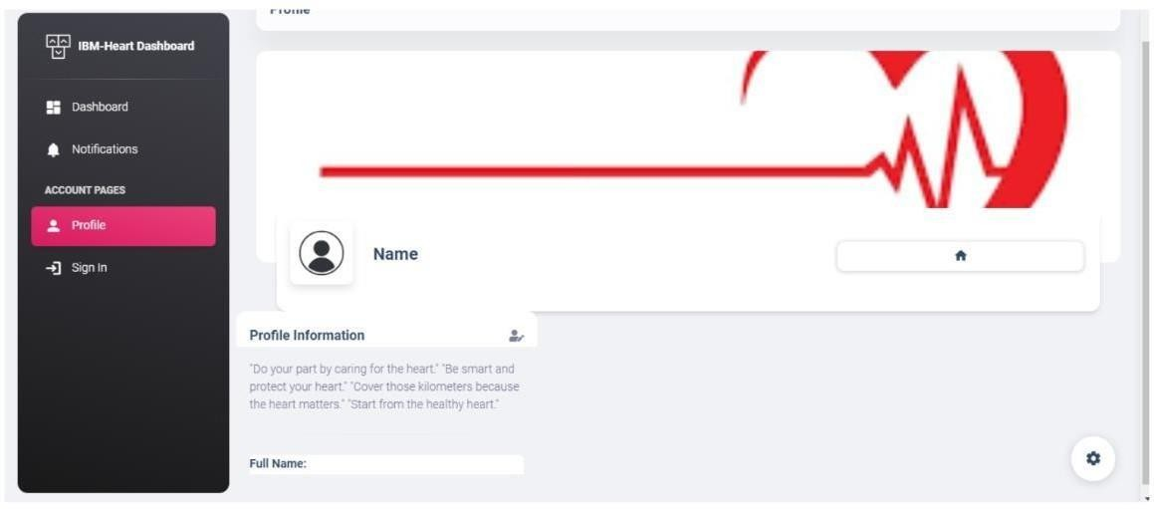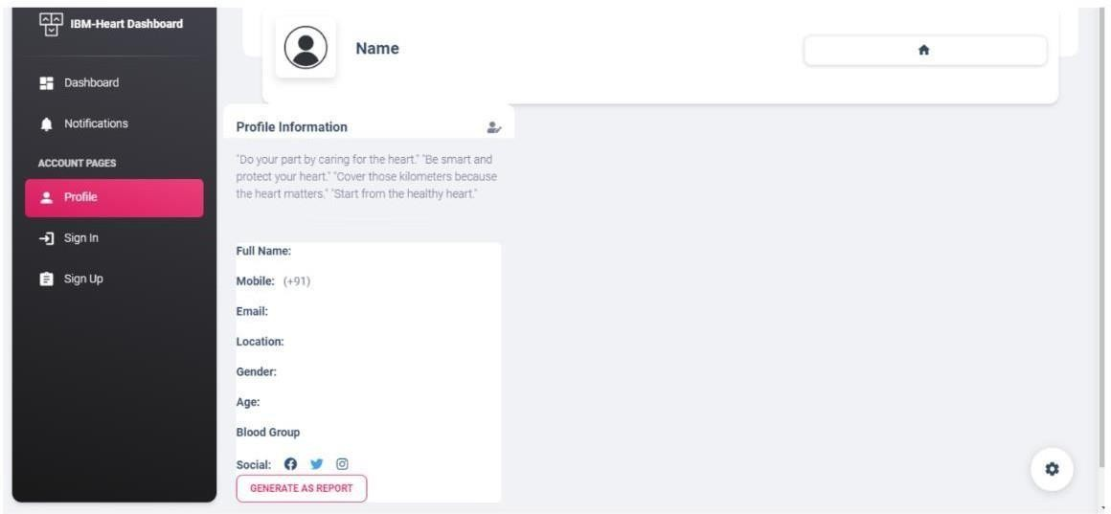

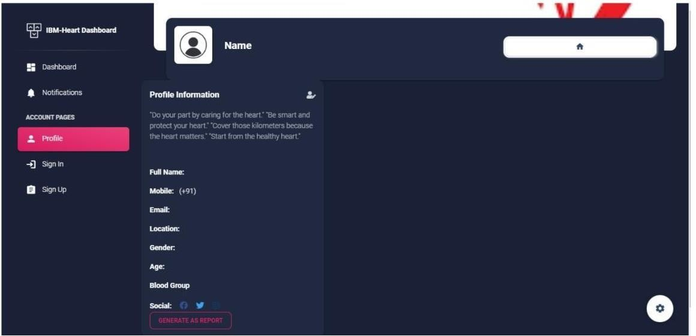

**Dataset collection** - The data required for analysis and prediction must be collected from various sources, Collecting Dataset from Different Site

